Walk the Line Film Study Name: ____________________

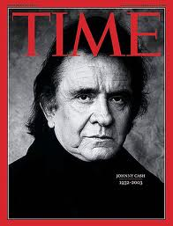
John R. "Johnny" Cash (February 26, 1932 – September 12, 2003) was an American singer-songwriter, actor, and author, who has been called one of the most influential musicians of the 20th century. (Wikipedia)

DUE DATE: _______

- Summarize the movie. (10%)

- Define Career as outlined in the glossary of the text. Use this definition to describe Johnny’s career as depicted in the movie. (20%)

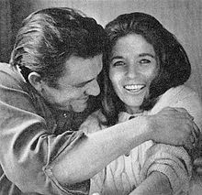
- Analyze the choices Johnny Cash made throughout his life. Many choices he made were influenced by family, friends, media, income, and enemies. Discuss two healthy and two unhealthy choices Mr. Cash made and explain how these choices impacted his life roles and career. (Consider things like recording the first record, dating June Carter, using drugs, and so on). (35%)

- Johnny Cash’s father made reference to the fact that his son had lots of money, but he still had nothing. Explain what the implications of this statement. (10%)

- Imagine it is 1960 and Johnny Cash has come to you for help. He feels like he made some wrong choices with his career. Based on your expertise of self-assessment, decision making, and change, write a career profile for Johnny Cash and advise him for his future. To complete this profile you need to use your knowledge of interests inventories, values, multiple intelligence, personalities, learning styles, decision making, change, and any other assessment tool you have at your disposal. (25%)
