What are My Abilities?

There are more ways of being smart than just “school smart.” Many people accept the theory of multiple intelligences, Most of us are dominant in three of four areas

You can be smart in more than one way; refer to the graphic below

What’s your MI?

Complete the activity on pages 42 – 43, using BLM 17 following three pages.

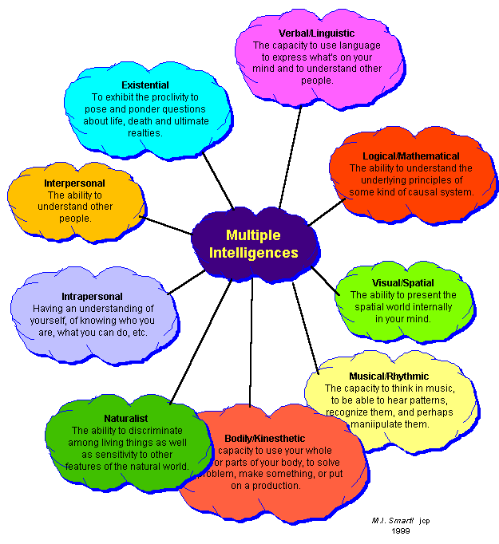

NAME: DATE:

What’s your MI?, p.42 BLM 17

1. On a scale of 1 (not at all like me) to 5 (definitely me), my rating for the following intelligences is:

MI QUIZ PERSONAL RATING

Verbal / linguistic

1. I like puns and other wordplay.

2. I enjoy doing crossword puzzles and playing games like Scrabble™.

3. I remember things exactly as they are said to me.

4. I like to take part in debates or discussions.

5. I prefer long and short written answers over multiple-choice responses.

6. I enjoy keeping a journal and/or writing stories and articles.

7. I like to read.

TOTAL FOR VERBAL / LINGUISTIC INTELLIGENCE

Logical / mathematical

1. I work best at an organized work area.

2. I enjoy math and/or science.

3. I keep a “things to do” list.

4. I enjoy brainteasers and games such as Jeopardy™ and Clue™.

5. I like to ask “why” questions about issues and concerns.

6. I quickly grasp cause-and-effect relationships.

7. I am good at estimations.

TOTAL FOR LOGICAL / MATHEMATICAL INTELLIGENCE

Visual / spatial

1. I understand what colours work well together.

2. I enjoy solving jigsaws, mazes and/or other visual puzzles.

3. I read charts and maps easily.

4. I have a good sense of direction.

5. I like to watch movies.

6. I have very vivid dreams.

7. I can anticipate the moves in a game plan (“hockey sense,” “chess sense”).

TOTAL FOR VISUAL / SPATIAL INTELLIGENCE

The Multiple Intelligence Chart and Quiz have been reproduced from Canada Prospects 1999-2000. Canada Prospects is published by Canada Career
Consortium.

Portfolio Activities © Copyright 2007 by Thomson Nelson

What’s your MI?, p.42 (continued) BLM 17

MI QUIZ PERSONAL RATING

Interpersonal

1. I interact well with people.

2. I enjoy team sports rather than individual sports.

3. Being around people energizes me.

4. I like group activities better than ones I do alone.

5. I enjoy learning about different cultures.

6. I usually talk over my personal problems with a friend.

7. I enjoy sharing my ideas and feelings with others.

TOTAL FOR INTERPERSONAL INTELLIGENCE

Intrapersonal

1. I am a private person, and I like my private inner world.

2. I have a few close friends.

3. I have strong opinions about controversial issues.

4. I work best when the activity is self-paced.

5. I am not easily influenced by others.

6. I understand my feelings, and know how I will react to situations.

7. I understand that I am responsible for my own behaviour.

TOTAL FOR INTRAPERSONAL INTELLIGENCE

Bodily / kinesthetic

1. I like to move, tap or fidget when sitting.

2. I participate in extreme sports (sea kayaking, snowboarding, mountain biking).

3. I tend to touch objects to examine their textures.

4. I am well coordinated.

5. I like working with my hands.

6. I prefer being physically involved to sitting and watching.

7. I understand better by doing (touching, moving and interacting).

TOTAL FOR BODILY / KINESTHETIC INTELLIGENCE

© Copyright 2007 by Thomson Nelson Portfolio Activities

What’s your MI?, p.42 (continued) BLM 17
MIUIZ PERSONAL RATING

Musical / rhythmic

1. I play music in my head.

2. I make up rhymes to remember things.

3. It is easy for me to follow the beat of music.

4. I like setting songs and poems to music.

5. I keep time when music is playing.

6. I can hear an off-key note.

7. I feel proud of my musical accomplishments.

TOTAL FOR MUSCIAL / RYTHMIC INTELLIGENCE

Naturalist

1. I have a collection (e.g., shells, mugs, rocks, hockey cards).

2. I notice similarities and differences in trees, flowers and other things in nature.

3. I am actively involved in protecting the environment.

4. I enjoy digging for artifacts and finding unusual items.

5. I like planting and caring for a garden.

6. I enjoy fishing and tracking.

7. I learn best when I can go on field trips—outdoors, or to museums.

TOTAL FOR NATURALIST INTELLIGENCE

2. My top four intelligences are:

1.

2.

3.

4.

